**Homeworks with Modern Tools and Concepts**

**CSE487 Cybersecurity, Law and Ethics**

**HW01. Caesar Cipher Implementation 3**

**HW02. MTU vs. MSS 4**

**HW03. Exterior Gateway Protocol (BGP and ASN) 5**

**Week 2 Homework 3. Implement at least three cipher algorithms of different types. 6**

**Week 2 Homework 4. Working with a virtual machine 7**

**Week 2 Homework 5. Complete the Linux Fundamentals Part 1 8**

**Week 2 Homework 6. Pass up to level 14 in Bandit Wargame 9**

**Week 2 Homework 7. Configure root CA, sub CA, and a server that uses https:// 10**

**Week 3 Homework 9. Configure a Web server 11**

**Week 3 Homework 8. Configure a DNS server 12**

**Week 3 Homework 9. Password Cracking 13**

**Week 3 Homework 10. Apply Mask attack on the hash using hashcat. 15**

**Week 3 Homework 11. Understand the basics and problems of Diffie-Hellman Key Exchange 17**

**Week 3 Homework 12: Familiarize yourself with the Cryptography library 18**

**Week 4 Homework 13: Understanding the RSA Algorithm 19**

**Week 4 Homework 14: Steganography 21**

**Week 4 Homework 15. Understanding TLS and decrypting HTTPS traffic 22**

**Week 4 Homework 16. Extract the values of the exponent and modulus from the SSL certificate 23**

**Week 5 Homework 17: Practical Cryptography Requirements 24**

**Week 5 Homework 18: Modern Encryption and Digital Signatures 24**

**Week 5 and onward: Project: Public Key Infrastructure Implementation 27**

**Attack Glossary: 28**

**Law and Ethics Part 32**

Data Protection 32

Principles of Data Collection and Use 32

General Data Protection Regulation (GDPR) 32

Children's Online Privacy Protection Act (COPPA) 33

**Mini Project-2: 33**

The Digital Security Act of 2018 (Bangladesh) 33

Official Secrets Act of 1923 33

Regulation of AI 34

Bangladesh Data Protection Act (Draft) 34

OTT Regulation Act (Draft) 35

Freedom of expression at Cyberspace 35

Intellectual Property 35

Ethics for Computer Science Engineers, and IT Professionals 36

**Mini Project-3: Present an ethical dilemma in decision making in the field of IT. 40**

**Knowledgebase 42**

Hash Functions 42

Security Operations Center (SOC) 42

Smurf Attack 43

Teardrop Attack 43

**Concepts**

**<Midterm-1>**

**Open a Repository on Github, and create folders for each of the assignments you work on.**

**Write documentations and create demos of your project on YouTube.**

# 

# HW01. Caesar Cipher Implementation

**Resources:**

* [Caesar Cipher in Python - Javatpoint](https://www.javatpoint.com/caesar-cipher-in-python)
* [Caesar Cipher in Cryptography - GeeksforGeeks](https://www.geeksforgeeks.org/caesar-cipher-in-cryptography)
* [Cryptography with Python - Caesar Cipher](https://www.tutorialspoint.com/cryptography_with_python/cryptography_with_python_caesar_cipher.htm)
* [Caesar Cipher In Python (Text Encryption Tutorial) - Like Geeks](https://likegeeks.com/python-caesar-cipher/) [*best*]
* [Python: Create a Caesar encryption - w3resource](https://www.w3resource.com/python-exercises/string/python-data-type-string-exercise-25.php) [*with step-by-step visualization*]

**Tasks:**

1. Implement Caesar Cipher in any programming language.

cipher_text = caesar_cipher (plain_text, shift)

1. Break the cipher using brute force (i.e., trying all possible combinations).
2. Attempt to break the cipher using **cryptanalysis** (e.g., perform letter frequency analysis on the ciphertext and try to match with the letter frequency in English Language). How can you be sure that you found the right key? [*challenging-task*]

**Delivery:** Demonstrate your work while recording the screen, upload the video on YouTube.

**Deadline: None. However, it is expected that you complete the tasks by the first week.**

**Questions:**

1. What is the difference between encoding and decoding?
2. What is the difference between encryption and decryption?
3. What is the difference between encoding and encryption?
4. Name an encoding algorithm.
5. Name an encryption algorithm.
6. What is a brute-force?
7. What is cryptography, cryptology and cryptanalysis?
8. Explain the letter frequency analysis attack on Caesar Cipher.
9. Discuss the strength of Caesar Cipher.

# 

# HW02. MTU vs. MSS

**Resources:**

* [Find a Path's MTU/MSS using PING Command Windows, Linux, Etc](https://www.pcwdld.com/ping-mtu#wbounce-modal)
* [How TCP Works - MTU vs MSShttps://youtu.be/XMcYwr-yJGA](https://youtu.be/XMcYwr-yJGA)
* netsh command (Windows):

#netsh interface ipv4 show subinterfaces

**Tasks:**

1. Write a computer program to discover the MTU and MSS size of your communication network.
2. What is the difference between MTU and MSS?
3. Compare the discovered MSS with the MTU size displayed in your operating system. Explain the reason, with a diagram.

**Delivery:** Demonstrate your work while recording the screen, upload the video on YouTube.

**Deadline: None. However, it is expected that you complete the tasks by the first week.**

**Questions:**

1. How did you discover the MTU/MSS on your system with the PING command?
2. What is the role of the DF flag?
3. Write the command to send an ICMP ping request to 8.8.8.8 of size 5000 Bytes with DF set to one.

# HW03. Exterior Gateway Protocol (BGP and ASN)

**Information: 2021 Facebook Outage**

* [Facebook, Instagram and WhatsApp down in global outage](https://www.youtube.com/watch?v=g2rk1MA-aLU)

<https://www.youtube.com/watch?v=g2rk1MA-aLU>

* [Why was Facebook down for five hours?](https://www.youtube.com/watch?v=-wMU8vmfaYo&t=520s)

<https://www.youtube.com/watch?v=-wMU8vmfaYo&t=520s>

* [Why Did Facebook Go Down? - Computerphile](https://www.youtube.com/watch?v=Bie32IZlMtY)

<https://www.youtube.com/watch?v=Bie32IZlMtY>

* **Facebook's explanation**: [More details about the October 4 outage - Engineering at Meta](https://engineering.fb.com/2021/10/05/networking-traffic/outage-details/)

<https://engineering.fb.com/2021/10/05/networking-traffic/outage-details/>

* [AS138578 East West University BGP Network Information - BGPView](https://bgpview.io/asn/138578#info)

<https://bgpview.io/asn/138578#info>

* [What is BGP? | BGP routing explained | Cloudflare](https://www.cloudflare.com/learning/security/glossary/what-is-bgp/)

<https://www.cloudflare.com/learning/security/glossary/what-is-bgp/>

**Tasks:**

Learn the difference between Interior Gateway Protocols and Exterior Gateway Protocols.

**Questions:**

1. What kind of protocol is BGP?
2. What is an AS Number? How is it related to BGP?
3. Find the AS number, Country, Registrar organization, and the list of allocated public IP addresses of the following organizations:
   1. Meta (Facebook, Instagram and WhatsApp)
   2. Grameenphone
   3. East West University
   4. Your Home ISP

|  |  |  |  |  |
| --- | --- | --- | --- | --- |
| **Organization[1]** | **AS Number** | **Country** | **Registrar Organization (RIR)** | **Allocated Public IP Addresses** |
| KTH - Royal Institute of Technology | AS2839 | Sweden | RIPE | 130.229.128.0/18  192.16.140.0/24  192.16.145.0/24  192.16.146.0/24 |

1. What other information can you extract from an ASN?
2. What is an RIR? What are the names of the five RIRs?

# 

# Week 2 Homework 3. Implement at least three cipher algorithms of different types.

[Difference between Monoalphabetic Cipher and Polyalphabetic Cipher](https://www.geeksforgeeks.org/difference-between-monoalphabetic-cipher-and-polyalphabetic-cipher/?ref=lbp)

<https://www.geeksforgeeks.org/difference-between-monoalphabetic-cipher-and-polyalphabetic-cipher/?ref=lbp>

Transposition, Substitution, Monoalphabetic, [Polyalphabetic Cipher](https://www.geeksforgeeks.org/difference-between-monoalphabetic-cipher-and-polyalphabetic-cipher/?ref=lbp)

PlayFair Cipher, Polyalphabetic

One Time Pad, Vigenere Tableau,

**Information: Understand the difference between encoding and encryption.**

encoding is conversion. a secret key is not required.

encryption is transformation. a secret key is required. The secrecy of the encryption depends on the secrecy of the secret key (Kerckhoff's Principle) .

The reverse process of encoding is called decoding. The reverse process of encryption is called decryption.

Hash-ing is similar to encoding but it can not be decoded. When someone discovers the method of decoding a hash function, the hash function is "broken". For example, MD5 algorithm is broken, because it can be reversed.

Hash functions have some additional requirements, like fixed length output, avalanche effect, collision resistance and so on.

In class, a random student from the class will be asked to explain the **birthday attack** on the whiteboard. and how it is relevant to hashing and cracking.

# 

# HW04. Working with a virtual machine

1. Install Oracle Virtualbox or VMWare.
2. Download and install Xubuntu/Lubuntu/Linux Mint/Kali/Parrot/Debian or any other linux distro (debian-based systems preferred). Do not choose Kali Linux if your computer is of low configuration.
3. Take a snapshot (not screenshot) of the virtual machine and save it as “State 0”.
4. Delete everything in the computer with the following command as root.

# sudo rm -rf /*

1. And enjoy your beloved machine being destroyed in front of your eyes.
2. Restore the snapshot taken earlier which was saved as “State 0”.
3. Run update and upgrade:

# sudo apt-get update && sudo apt-get upgrade

# sudo apt-get dist-upgrade

1. Configure the network of the virtual machine to use a host-only network . Understand the difference among Bridged Adapter, NAT, Host-only network configurations.
2. Host-only networks have the ip address in the 192.168.56.0/24 subnet. Note down the IPv4 address of the virtual machine in a host-only network with the command

~ ip addr or ~ ifconfig

1. Change the hostname of the VM to “server”.
2. Clone the virtual machine, turn it on and change the hostname to “client”.
3. Check if the client (i.e., the cloned VM) is also configured to use the host-only network.
4. Ping from the server to the client and vice-versa to check the connectivity.

# 

# HW05. Complete the Linux Fundamentals Part 1

[TryHackMe | Linux Fundamentals Part 1](https://tryhackme.com/room/linuxfundamentalspart1)

<https://tryhackme.m/room/linuxfundamentalspart1>

# 

# HW06. Pass up to level 14 in Bandit Wargame

[OverTheWire: Bandit](https://overthewire.org/wargames/bandit/)

<https://overthewire.org/wargames/bandit/>

**Solution and Walkthrough:**

[OverTheWire - Bandit Walkthrough](https://home.adelphi.edu/~ni21347/cybersecgames/OverTheWire/Bandit/index.html)

<https://home.adelphi.edu/~ni21347/cybersecgames/OverTheWire/Bandit/index.html>

[OverTheWire-Wargames-Bandit Walkthrough | by Kanishka | Medium](https://medium.com/@Kan1shka9/overthewire-wargames-bandit-walkthrough-df2b86826c67)

<https://medium.com/@Kan1shka9/overthewire-wargames-bandit-walkthrough-df2b86826c67>

[OverTheWire – Bandit Walkthrough (1-14) - Hacking Articles](https://www.hackingarticles.in/overthewire-bandit-walkthrough-1-14/)

<https://www.hackingarticles.in/overthewire-bandit-walkthrough-1-14/>

[Over The Wire: WARGAMES;Bandit level 0 to 10 WALKTHROUGH | Medium | InfoSec Write-ups](https://infosecwriteups.com/over-the-wire-wargames-bandit-level-0-to-10-walkthrough-97015bfc6538)

<https://infosecwriteups.com/over-the-wire-wargames-bandit-level-0-to-10-walkthrough-97015bfc6538>

# 

# HW07. Configure root CA, sub CA, and a server that uses https://

Become a master of OpenSSL [Masterclass in openSSL](https://www.youtube.com/watch?v=d8OpUcHzTeg)

<https://www.youtube.com/watch?v=d8OpUcHzTeg>

Useful tools:

**XCA (OpenSSL GUI)**

<https://hohnstaedt.de/xca/index.php/download>

X - Certificate and Key management: This application is intended for creating and managing X.509 certificates, certificate requests, RSA, DSA and EC private keys, Smartcards and CRLs.

Everything that is needed for a CA could be done with XCA (instead of OpenSSL).

# 

# Week 3 Homework 9. Configure a Web server

Install and configure Apache2.

[Install and Configure Apache | Ubuntu](https://ubuntu.com/tutorials/install-and-configure-apache)

<https://ubuntu.com/tutorials/install-and-configure-apache>

[How To Install the Apache Web Server on Ubuntu 22.04 | DigitalOcean](https://www.digitalocean.com/community/tutorials/how-to-install-the-apache-web-server-on-ubuntu-22-04)

<https://www.digitalocean.com/community/tutorials/how-to-install-the-apache-web-server-on-ubuntu-22-04>

Learn more about server hardening:

[How to-Ubuntu Hardening Security Best Practices Checklist](https://cloudinfrastructureservices.co.uk/how-to-ubuntu-hardening-security-best-practices-checklist/)

<https://gist.github.com/mirajehossain/59c6e62fcdc84ca1e28b6a048038676c>

<https://github.com/konstruktoid/hardening>

<https://dewapost.com/2022/03/19/how-to-hardening-the-ubuntu-server/>

Add a new user for the apache2 web service

# 

# Week 3 Homework 8. Configure a DNS server

[**An Introduction to DNS Terminology, Components, and Concepts | DigitalOcean**](https://www.digitalocean.com/community/tutorials/an-introduction-to-dns-terminology-components-and-concepts)

[**https://www.digitalocean.com/community/tutorials/an-introduction-to-dns-terminology-components-and-concepts**](https://www.digitalocean.com/community/tutorials/an-introduction-to-dns-terminology-components-and-concepts)

[**Linux DNS Server - YouTube**](https://www.youtube.com/playlist?list=PL291a0KYQZSK6E_1j9xkkieCOi_867pyc) **[*Full Course*]**

[**https://www.youtube.com/playlist?list=PL291a0KYQZSK6E_1j9xkkieCOi_867pyc**](https://www.youtube.com/playlist?list=PL291a0KYQZSK6E_1j9xkkieCOi_867pyc)

# 

# Week 3 Homework 9. Password Cracking

You want to find somone’s password. But all you have is some hash value of the password.

Like: **e4760b8c578faff251538fe7be740bf801161304e5b11553d76a10e79219de6f**

A hash value is also known as a “digest”.

* **Identify the hashing algorithm.**

Try to identify the hashing algorithm from the digest length. Which one it could be?

len("e4760b8c578faff251538fe7be740bf801161304e5b11553d76a10e79219de6f")

= 64

# So, the length is 64.

sorted(set("e4760b8c578faff251538fe7be740bf801161304e5b11553d76a10e79219de6f"))

= ['0', '1', '2', '3', '4', '5', '6', '7', '8', '9', 'a', 'b', 'c', 'd', 'e', 'f']

# So, these could be Hexadecimal values. Since, Hexadecimal is a 4-bit representation of binary, therefore the following is true:

len("e4760b8c578faff251538fe7be740bf801161304e5b11553d76a10e79219de6f")

= 64 Hex Values

= 64 * 4 bits = 256 bits.

Ask your best friend about it:

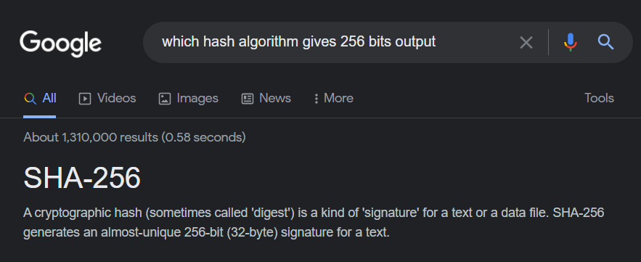

Now you have to reverse the hash function to find out

***for which input, this particular SHA256 value is the output?***

That means, if **x** is the password, you have to find **x** where,

sha256sum(**x**) = e4760b8c578faff251538fe7be740bf801161304e5b11553d76a10e79219de6f

The password could be a permutations of:

* Some or all digits of a phone number
* Some or all digits of any date (e.g., birthday, marriage day, some other day)
* Recent years/months, around the victim’s birth year/month,
* Name of a person, location, school, university.
* Something relevant to the person
* Weak passwords like abc123, 123456, password, iloveyou

You can either launch a Brute Force attack or a Dictionary attack against the digest to find the password. If Brute Force is not feasible, a dictionary (wordlist) of common passwords can be used to match the hash.

So, a hash cracking program should go through each of the lines (1 word per line) and calculate the hash value for that word, and compare the digest with the given digest. Keep trying until a match is found.

1. Calculate the time required to Brute Force the password with 4000 passwords per second.
2. Generate a dictionary/wordlist using *Crunch*.

[Comprehensive Guide on Crunch Tool - Hacking Articles](https://www.hackingarticles.in/comprehensive-guide-on-crunch-tool/)

<https://www.hackingarticles.in/comprehensive-guide-on-crunch-tool/>

1. What is the dictionary size?
2. Use *Hashcat* to break the password using the dictionary created with *Crunch*.
3. How long would your system CPU or GPU take to try this wordlist to find the actual password?

You can modify your code to use the GPU if it takes too long.

1. How is “*John The Ripper*” relevant? Is it better or worse?

You can generate the wordlist on the fly (without generating a wordlist) using *Crunch* and pipe the output to *Hashcat*.

1. What is a “Rainbow Table”? What is a “salt”? How are these two relevant to cryptology and password cracking?
2. Understand how SHA256 is calculated. [*Bonus*]
3. Specify some modern tools for password cracking. [*Bonus*]

[Taking Password Cracking to the Next Level – CryptoKait](https://cryptokait.com/2020/09/02/taking-password-cracking-to-the-next-level/)

<https://cryptokait.com/2020/09/02/taking-password-cracking-to-the-next-level/>

**Hint: Cracking a hash with hashcat:**

**Given that,**

**sha256 (“CSE487”) = e4760b8c578faff251538fe7be740bf801161304e5b11553d76a10e79219de6f**

The input CSE487 contains 3 uppercase characters and 3 digits. Therefore the pattern for hashcat would be:

**?u?u?u?d?d?d**

Where ?u denotes all UPPERCASE characters and ?d denotes all digits. Learn more from the manual of hashcat. <https://manpages.org/hashcat> or type “man hashcat” in a Linux terminal.

Install hashcat on your Windows host [virtual machines will generate error: illegal hardware instruction ]

# 

# Week 3 Homework 10. Apply Mask attack on the hash using hashcat.

[mask_attack [hashcat wiki]](https://hashcat.net/wiki/doku.php?id=mask_attack)

<https://hashcat.net/wiki/doku.php?id=mask_attack>

**Command Syntax:**

hashcat -m <hash type> -a <attack type> <hash value> <pattern>

**Example:**

hashcat -m 1400 -a 3 e4760b8c578faff251538fe7be740bf801161304e5b11553d76a10e79219de6f ?u?u?u?d?d?d

|  |
| --- |
| C:\Users\mcctu\Downloads\Compressed\hashcat-6.2.5>hashcat -m 1400 -a 3 e4760b8c578faff251538fe7be740bf801161304e5b11553d76a10e79219de6f ?u?u?u?d?d?d  hashcat (v6.2.5) starting  OpenCL API (OpenCL 3.0 ) - Platform #1 [Intel(R) Corporation]  =============================================================  * Device #1: Intel(R) UHD Graphics, 1536/3173 MB (793 MB allocatable), 32MCU  Minimum password length supported by kernel: 0  Maximum password length supported by kernel: 256  Hashes: 1 digests; 1 unique digests, 1 unique salts  Bitmaps: 16 bits, 65536 entries, 0x0000ffff mask, 262144 bytes, 5/13 rotates  Optimizers applied:  * Zero-Byte  * Early-Skip  * Not-Salted  * Not-Iterated  * Single-Hash  * Single-Salt  * Brute-Force  * Raw-Hash  ATTENTION! Pure (unoptimized) backend kernels selected.  Pure kernels can crack longer passwords, but drastically reduce performance.  If you want to switch to optimized kernels, append -O to your command line.  See the above message to find out about the exact limits.  Watchdog: Hardware monitoring interface not found on your system.  Watchdog: Temperature abort trigger disabled.  Host memory required for this attack: 579 MB  The wordlist or mask that you are using is too small.  This means that hashcat cannot use the full parallel power of your device(s).  Unless you supply more work, your cracking speed will drop.  For tips on supplying more work, see: https://hashcat.net/faq/morework  Approaching final keyspace - workload adjusted.  e4760b8c578faff251538fe7be740bf801161304e5b11553d76a10e79219de6f:**CSE487**  Session..........: hashcat  Status...........: Cracked  Hash.Mode........: 1400 (SHA2-256)  Hash.Target......: e4760b8c578faff251538fe7be740bf801161304e5b11553d76...19de6f  Time.Started.....: Thu Mar 03 19:37:21 2022 (1 sec)  Time.Estimated...: Thu Mar 03 19:37:22 2022 (0 secs)  Kernel.Feature...: Pure Kernel  Guess.Mask.......: ?u?u?u?d?d?d [6]  Guess.Queue......: 1/1 (100.00%)  Speed.#1.........: 9483.3 kH/s (0.17ms) @ Accel:128 Loops:10 Thr:16 Vec:1  Recovered........: 1/1 (100.00%) Digests  Progress.........: 4342784/17576000 (24.71%)  Rejected.........: 0/4342784 (0.00%)  Restore.Point....: 6144/26000 (23.63%)  Restore.Sub.#1...: Salt:0 Amplifier:360-370 Iteration:0-10  Candidate.Engine.: Device Generator  Candidates.#1....: ZBT691 -> JSQ391  Started: Thu Mar 03 19:37:17 2022  Stopped: Thu Mar 03 19:37:24 2022 |

# 

# Week 3 Homework 11. Understand the basics and problems of Diffie-Hellman Key Exchange

Used to generate/agree upon a symmetric key in the presence of an eavesdropper.

[Secret Key Exchange (Diffie-Hellman) - Computerphile](https://www.youtube.com/watch?v=NmM9HA2MQGI)

<https://www.youtube.com/watch?v=NmM9HA2MQGI>

[Diffie Hellman -the Mathematics bit- Computerphile](https://www.youtube.com/watch?v=Yjrfm_oRO0w)

<https://www.youtube.com/watch?v=Yjrfm_oRO0w>

[Diffie Hellman Key Exchange Algorithm | Complete Working with Diagram & Example](https://www.youtube.com/watch?v=xSUMEer6J_E)

<https://www.youtube.com/watch?v=xSUMEer6J_E>

[Public key cryptography - Diffie-Hellman Key Exchange (full version)](https://www.youtube.com/watch?v=YEBfamv-_do)

<https://www.youtube.com/watch?v=YEBfamv-_do>

[Public Key Cryptography: Diffie-Hellman Key Exchange (short version)](https://youtu.be/3QnD2c4Xovk)

<https://youtu.be/3QnD2c4Xovk>

[Gambling with Secrets: Part 7/8 (Diffie-Hellman Key Exchange)](https://www.youtube.com/watch?v=6NcDVERzMGw)

<https://www.youtube.com/watch?v=6NcDVERzMGw>

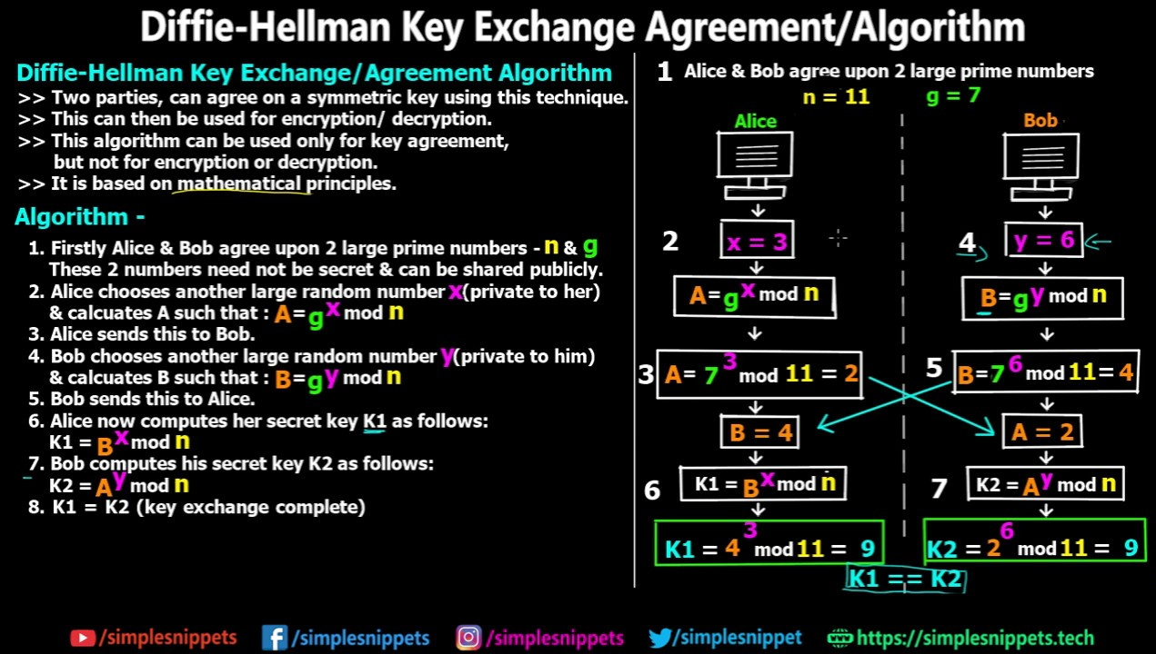

# 

# Week 3 Homework 12: Familiarize yourself with the Cryptography library

How to Encrypt and Decrypt Data in Python using Cryptography Library

<https://devqa.io/encrypt-decrypt-data-python/>

How to Encrypt and Decrypt Strings in Python?

<https://www.geeksforgeeks.org/how-to-encrypt-and-decrypt-strings-in-python/>

How to calculate hash using hashlib?

[SHA256 Encryption with Python by Josh Dwernychuk | Medium](https://medium.com/@dwernychukjosh/sha256-encryption-with-python-bf216db497f9)

<https://medium.com/@dwernychukjosh/sha256-encryption-with-python-bf216db497f9>

import hashlib

def hash(string):

sha_signature = hashlib.sha256(string.encode()).hexdigest()

return sha_signature

string = 'CSE487'

sha_signature = hash(string)

print(sha_signature)

# e4760b8c578faff251538fe7be740bf801161304e5b11553d76a10e79219de6f

**Information: Understanding Encryption**

[Gambling with Secrets (Cryptography) - YouTube](https://www.youtube.com/playlist?list=PLB4D701646DAF0817)

<https://www.youtube.com/playlist?list=PLB4D701646DAF0817>

# 

# Week 4 Homework 13: Understanding the RSA Algorithm

**Read section 9.2 of the Cryptography and Network Security by William Stallings**

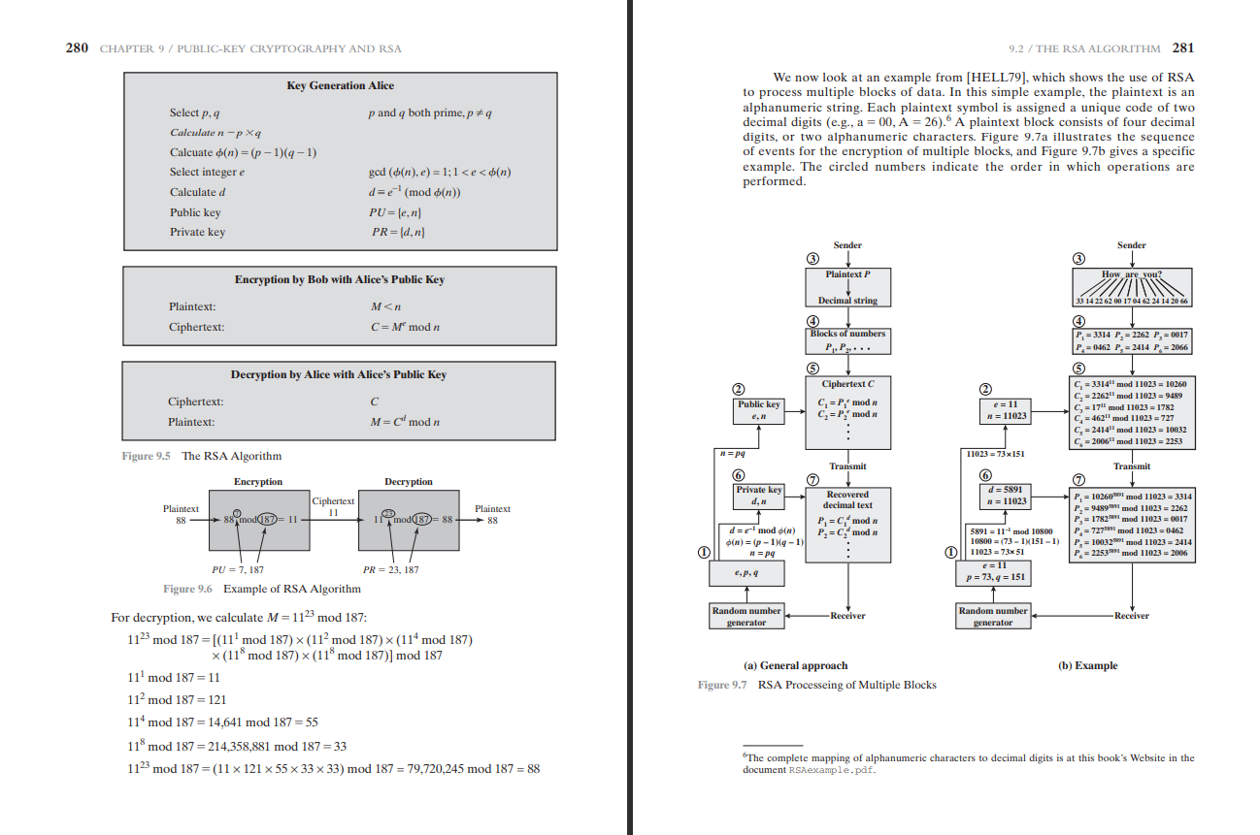

[Public Key Cryptography: RSA Encryption Algorithm](https://www.youtube.com/watch?v=wXB-V_Keiu8)

<https://www.youtube.com/watch?v=wXB-V_Keiu8>

[Gambling with Secrets: 8/8 (RSA Encryption)](https://www.youtube.com/watch?v=vgTtHV04xRI)

<https://www.youtube.com/watch?v=vgTtHV04xRI>

[How does RSA work? | HackerNoon](https://hackernoon.com/how-does-rsa-work-f44918df914b)

<https://hackernoon.com/how-does-rsa-work-f44918df914b>

[An Introduction to Public Key Cryptosystems with RSA | by Andrew Oliver | HackerNoon.com | Medium](https://medium.com/hackernoon/an-introduction-to-public-key-cryptosystems-with-rsa-7e34cc67cf22)

<https://medium.com/hackernoon/an-introduction-to-public-key-cryptosystems-with-rsa-7e34cc67cf22>

[Open the link in a Private/Incognito window if the site asks for money]

**Learn easy-rsa**

Linux tool.

**RSA Algorithm Implementation in Python**

<https://github.com/andrewjoliver/rsa_implementation/blob/master/rsa_algorithm.py>

**RSA Calculator:**

[RSA Calculator by Syed Umar Anis](https://umaranis.com/rsa_calculator_demo.html)

<https://umaranis.com/rsa_calculator_demo.html>

[RSA Calculator](https://www.cs.drexel.edu/~jpopyack/IntroCS/HW/RSAWorksheet.html)

<https://www.cs.drexel.edu/~jpopyack/IntroCS/HW/RSAWorksheet.html>

[Online RSA key generation](https://www.mobilefish.com/services/rsa_key_generation/rsa_key_generation.php)

<https://www.mobilefish.com/services/rsa_key_generation/rsa_key_generation.php>

RSA Cipher

<https://www.dcode.fr/rsa-cipher>

# 

# Week 4 Homework 14: Steganography

LSB steganography:

<https://github.com/livz/cloacked-pixel>

Reliable detection of LSB Steganography is still a problem.

<https://github.com/RobinDavid/LSB-Steganography>

Python program based on steganographic methods to hide files in images using the Least Significant Bit technique.

[Steganography - A list of useful tools and resources - 0xRick’s Blog](https://0xrick.github.io/lists/stego/)

<https://0xrick.github.io/lists/stego/>

[**OpenStego**](https://www.openstego.com/) **for Data Hiding and Digital Watermarking**

<https://www.openstego.com/> [requires java]

Concepts: <https://www.openstego.com/concepts.html>

Tutorial: [Conceal Any Data with OpenStego](https://medium.com/codex/conceal-any-data-with-openstego-7dcc908d3497)

<https://medium.com/codex/conceal-any-data-with-openstego-7dcc908d3497>

# 

# Week 4 Homework 15. Understanding TLS and decrypting HTTPS traffic

[Analyzing TLS session setup using Wireshark](https://www.youtube.com/watch?v=MQg48n9lV0s)

<https://www.youtube.com/watch?v=MQg48n9lV0s>

Decrypting HTTPS (SSL/TLS+HTTP):

<https://www.comparitech.com/net-admin/decrypt-ssl-with-wireshark/>

# 

# Week 4 Homework 16. Extract the values of the exponent and modulus from the SSL certificate

Open the SSL certificate by clicking on the Padlock icon in the address bar of your browser. Export the certificate as "*ewubd SSL cert.cer*". By default, Windows exports it as a DER formatted file with *\*.cer* extension, but it needs to be converted to PEM format. Then OpenSSL can extract the public key from the PEM formatted certificate.

The public key can be extracted from the certificate "*ewubd SSL cert.cer*" (in DER format) with following steps with **OpenSSL**:

**Convert the DER formatted certificate "*ewubd SSL cert.cer*" to PEM format and save it as "*ewubd SSL cert.pem*" :**

C:\OpenSSL\bin>openssl x509 -inform der -in "ewubd SSL cert.cer" -out "ewubd SSL cert.pem"

**View the certificate:** C:\OpenSSL\bin>type " ewubd SSL cert.cer "

Use catinstead of typein Linux systems.

**Extract the public key as "ewubd PUB key.key" from the PEM formatted certificate:**

C:\OpenSSL\bin>openssl x509 -pubkey -in "ewubd SSL cert.pem" -noout > "ewubd PUB key.key"

**View the public key:**

C:\OpenSSL\bin>type "ewubd PUB key.key"

-----BEGIN PUBLIC KEY-----

MIIBIjANBgkqhkiG9w0BAQEh

[truncated] QIDAQAB

-----END PUBLIC KEY-----

**View the exponent and modulus:**

C:\OpenSSL\bin>openssl rsa -pubin -in "ewubd PUB key.key" -text -noout

Public-Key: (2048 bit)

Modulus:

00:d2:a5:2c:35:d0:e6:0a:e7:4e:d0:de:83:80:94:

[truncated]

b1:85

Exponent: 8193 (0x10001)

**</Midterm-1>**

**<Midterm-2>**

# Week 5 Homework 17: Practical Cryptography Requirements

Properties of good hash function, encryption and decryption functions.

Rainbow Tables

Birthday Attack

Strengthening hash functions with Salt

Random and Pseudorandom Number Generation

# Week 5 Homework 18: Modern Encryption and Digital Signatures

Message Authentication Code (MAC)

HMAC

DH Key Exchange

RSA Algorithm and e = 65537

ECC Algorithm and NISTs 4th EC graph

[Elliptic Curve Cryptography Tutorial - Understanding ECC through the Diffie-Hellman Key Exchange](https://www.youtube.com/watch?v=gAtBM06xwaw)

<https://www.youtube.com/watch?v=gAtBM06xwaw>

AES Encryption

[AES Explained (Advanced Encryption Standard) - Computerphile](https://www.youtube.com/watch?v=O4xNJsjtN6E)

<https://www.youtube.com/watch?v=O4xNJsjtN6E>

3DES Encryption

Known plaintext attack on DES and 2DES algorithms.

[The Trick That Solves Rubik’s Cubes and Breaks Ciphers (Meet in the Middle)](https://youtu.be/wL3uWO-KLUE)

<https://youtu.be/wL3uWO-KLUE>

**HWXX. Understanding different types of SSL Certificates**

Understand different levels of validation:

**Table 1: Validation Requirements for DV, OV, and EV Certificates**

|  |  |  |  |
| --- | --- | --- | --- |
| **Certificate Type** | **Domain Validation (DV)** | **Organization Validation (OV)** | **Extended Validation (EV)** |
| Domain Ownership Validation | Required | Required | Required |
| Organization Identity Validation | Not Required | Required | Required |
| Legal Existence Validation | Not Required | Required | Required |
| Physical Address Validation | Not Required | Required | Required |
| Telephone Number Validation | Not Required | Required | Required |
| Display of Organization Name | Not Required | Yes | Yes |
| Display of Padlock Icon | Yes | Yes | Yes |
| Display of Organization Name in Address Bar | No | No | Yes |
| Recommended for | Personal Websites, Blogs, Small Businesses | Small to Medium Businesses, E-commerce Sites, Financial Institutions | Large Enterprises, Financial Institutions, Healthcare Providers |

**Table 2: Certificate Details for DV, OV, and EV Certificates**

|  |  |  |  |
| --- | --- | --- | --- |
| **Certificate Type** | **Domain Validation (DV)** | **Organization Validation (OV)** | **Extended Validation (EV)** |
| Information Verified | Domain Ownership | Domain Ownership, Organization Identity, Legal Existence, Physical Address, Telephone Number | Domain Ownership, Organization Identity, Legal Existence, Physical Address, Telephone Number |
| Issuance Time | Minutes to Hours | Hours to Days | Days to Weeks |
| Cost | Lowest | Medium | Highest |
| Encryption Strength | Same as OV and EV | Same as DV and EV | Same as DV and OV |
| Trust Level | Minimal | Moderate | High |
| Recommended for | Personal Websites, Blogs, Small Businesses | Small to Medium Businesses, E-commerce Sites, Financial Institutions | Large Enterprises, Financial Institutions, Healthcare Providers |

|  |  |  |  |
| --- | --- | --- | --- |
| **Certificate Type** | **Validation Process** | **Information Displayed** | **Recommended Use** |
| Domain Validation (DV) | Verify domain ownership through email or DNS record | Domain name only | Personal websites, blogs, or non-commercial sites |
| Organization Validation (OV) | Verify domain ownership and legal existence, physical address, and telephone number of the organization | Organization name and location | Small to medium-sized businesses that want to establish trust with their customers |
| Extended Validation (EV) | Verify domain ownership, legal identity, and physical location of the organization | Organization name, location, and green address bar | E-commerce, finance, or healthcare websites that require the highest level of assurance for their customers |

Transport Layer Security

PKI

**Kerberos**

[Taming Kerberos - Computerphile](https://www.youtube.com/watch?v=qW361k3-BtU)

<https://www.youtube.com/watch?v=qW361k3-BtU>

[Taming Kerberos -- Redmondmag.com](https://redmondmag.com/articles/2004/07/01/taming-kerberos.aspx) [*deep dive into Kerberos*]

<https://redmondmag.com/articles/2004/07/01/taming-kerberos.aspx>

[Kerberos Explained (In 3 Levels Of Detail)](https://www.youtube.com/watch?v=snGeZlDQL2Q)

<https://www.youtube.com/watch?v=snGeZlDQL2Q>

[Basic Kerberos Authentication](https://www.youtube.com/watch?v=u7MQoSN19O4)

<https://www.youtube.com/watch?v=u7MQoSN19O4>

[Kerberos Authentication Explained | A deep dive](https://www.youtube.com/watch?v=5N242XcKAsM)

<https://www.youtube.com/watch?v=5N242XcKAsM>

[MicroNugget: How Kerberos Works in Windows Active Directory | CBT Nuggets](https://www.youtube.com/watch?v=kp5d8Yv3-0c)

<https://www.youtube.com/watch?v=kp5d8Yv3-0c>

[Taming Kerberos – Revx0r](https://revx0r.com/taming-kerberos/)

<https://revx0r.com/taming-kerberos/>

OAuth2 / SAML /Shibboleth SSO

PGP

**A Tutorial for Beginners to PGP**

<https://sites.pitt.edu/~poole/PGP.htm>

OpenPGP: Key management tool

Email encryption with PGP (Flowcrypt)

VPN (IKE+IPSEC+Tunneling) and TOR

Secure Routing

Wireless Encryption Protocols (WEP, WPA/WPA2/WPA3)

# Week 5 and onward: Project: Public Key Infrastructure Implementation

Please see the project documentation

[CSE487-X-MP-X](https://docs.google.com/document/d/1E1e1OPPrNEJ_nyxqf-i4PltwPdY2w-hRPT17ZJ0Zk-0/edit?usp=sharing)

<https://docs.google.com/document/d/1E1e1OPPrNEJ_nyxqf-i4PltwPdY2w-hRPT17ZJ0Zk-0/edit?usp=sharing>

**Known Issues:**

* Only the RootCA certificate needs to be imported in the client computer/browser.
* The chained certificate must be converted in PEM format, containing three certificates for the RootCA, SubCA (the one who signed) and the server (the server that requests the signing of its certificate to the CA).
* The SSL certificate must be demonstrated from the Client computer, and must contain three tabs for the RootCA, SubCA and the server certificates.
* DNS must resolve both forward and reverse DNS queries.
* WebMin and XCA are not allowed.

**Useful tools:**

* Virtualbox or QEMU or VMWare Player
* A Debian based Linux OS
* Apache2/NginX
* OpenSSL
* XCA (OpenSSL GUI)
* <https://hohnstaedt.de/xca/index.php/download>

**Best Practices for Cybersecurity**

Effective Cybersecurity by William Stallings

<http://williamstallings.com/Cybersecurity/>

# Attack Glossary:

[OWASP Top Ten](https://owasp.org/www-project-top-ten/) Vulnerabilities

https://owasp.org/www-project-top-ten/

[Top 10 Most Common Types of Cyber Attacks](https://blog.netwrix.com/2018/05/15/top-10-most-common-types-of-cyber-attacks/)

<https://blog.netwrix.com/2018/05/15/top-10-most-common-types-of-cyber-attacks/>

[The 15 Most Common Types of Cyber Attacks](https://www.lepide.com/blog/the-15-most-common-types-of-cyber-attacks/)

<https://www.lepide.com/blog/the-15-most-common-types-of-cyber-attacks/>

1. DoS and DDoS

<https://en.wikipedia.org/wiki/Denial-of-service_attack>

TCP SYN Flood Attack

Teardrop attack

Smurf attack

Ping of death attack

Fork Bomb

[Fork bomb - Wikipedia](https://en.wikipedia.org/wiki/Fork_bomb)

[Fork bombs in lots of languages](https://github.com/aaronryank/fork-bomb)

[Understanding Bash fork() Bomb :(){ :|:& };: code - nixCraft](https://www.cyberciti.biz/faq/understanding-bash-fork-bomb/)

Botnets

Zombie

What is cloudflare?

2. Man-in-the-middle (MitM) attack

Session hijacking

IP Spoofing

Replay

Sniffing

3. Phishing and spear phishing attacks

4. Drive-by attack

5. Password attack

Brute-force: Crunch, John The Reaper, Hashcat

Dictionary attack: RockYou

Rainbow Table attack

Credential stuffing,

Password spraying

Keylogger

6. SQL injection attack

Buffer Overflow

7. Cross-site scripting (XSS) attack: BeeF XSS Framework

8. Eavesdropping attack: Active or Passive

9. Birthday attack

10. Malware attack

Macro viruses

File infectors

System or boot-record infectors

Polymorphic viruses

Stealth viruses

Trojans

Logic bombs

Worms

Droppers

Ransomware

Adware

Spyware

Social Engineering Attack

Phishing

Impersonation

Tailgating

Eavesdropping

Shoulder Surfing

Bluetooth Attacks

<https://hackernoon.com/how-to-hack-bluetooth-devices-5-common-vulnerabilities-ng2537af>

Business Email Compromise (BEC)

Phishing

Spear-phishing

Zero-day exploit

Active Persistent Threat

DNS Tunneling

DNS Cache Poisoning

Route poisoning

Cryptojacking

Cookie stealing

AI-Powered Attacks

IoT-Based Attacks

51% attack and other attacks on Blockchains

FAQs:

* What hash format are modern Windows login passwords stored in?
* What are automated tasks called in Linux?
* If a password hash starts with $6$, what format is it (Unix variant)?

Threats and Vulnerabilities

* What is the CVE for the 2020 Cross-Site Scripting (XSS) vulnerability found in WPForms?
* There was a Local Privilege Escalation vulnerability found in the Debian version of Apache Tomcat, back in 2016. What's the CVE for this vulnerability?
* What is the very first CVE found in the VLC media player?
* If you wanted to exploit a 2020 buffer overflow in the sudo program, which CVE would you use?

Correct answers are given below, transparency set to 100% to make the picture invisible.

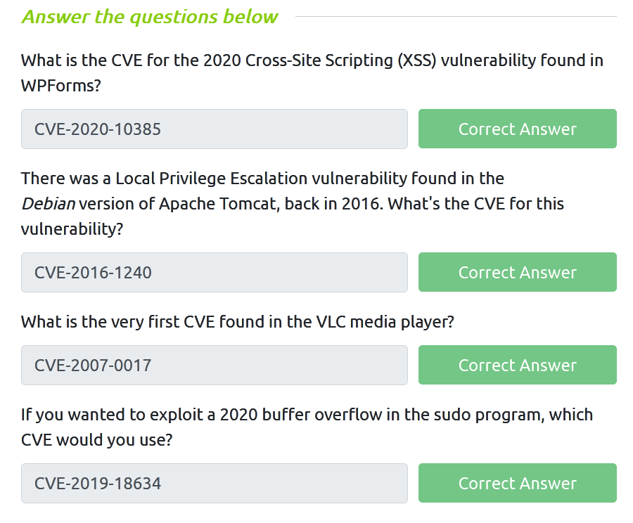

Answer the following questions using the man command:

SCP is a tool used to copy files from one computer to another.

What switch would you use to copy an entire directory?

fdisk is a command used to view and alter the partitioning scheme used on your hard drive.

What switch would you use to list the current partitions?

nano is an easy-to-use text editor for Linux. There are arguably better editors (Vim, being the obvious choice); however, nano is a great one to start with.

What switch would you use to make a backup when opening a file with nano?

Netcat is a basic tool used to manually send and receive network requests.

What command would you use to start netcat in listen mode, using port 12345?

Correct answers are given below, transparency set to 100% to make the picture invisible.

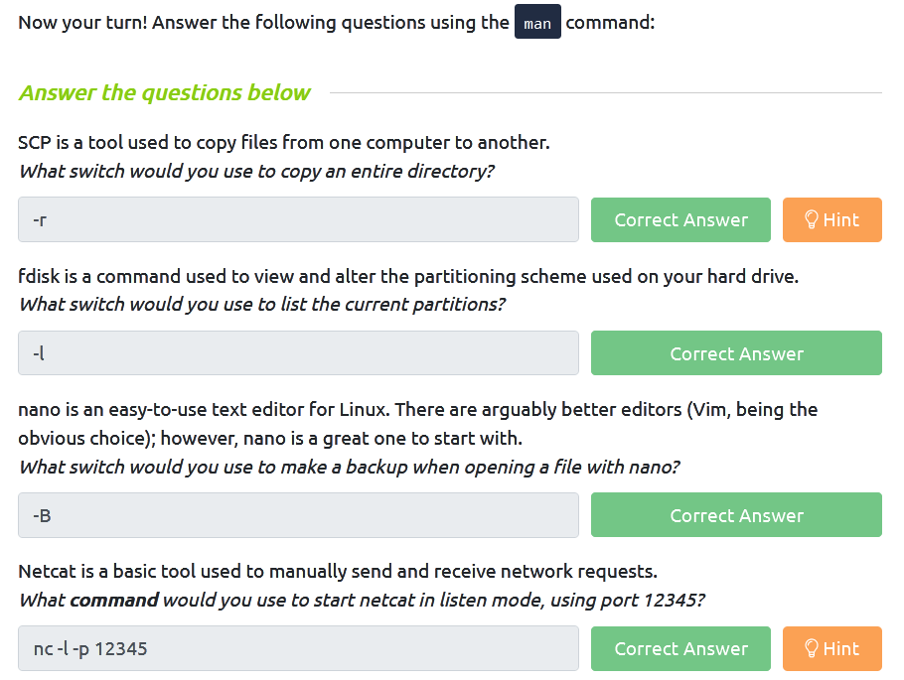

# Law and Ethics Part

## Data Protection

**There is a trade-off between Security and Privacy.**

**Watch the documentary:** [**The Great Hack**](https://www.google.com/search?q=the+great+hack+watch+online&oq=the+great+hack+watch+online&aqs=chrome..69i57j0i22i30.6210j0j7&sourceid=chrome&ie=UTF-8)

### Principles of Data Collection and Use

Resource: Class lecture and SPIC(6) slide in the Resources folder

### General Data Protection Regulation (GDPR)

How to Comply: [GDPR compliance](https://gdpr.eu/)

<https://gdpr.eu/>

Information about [GDPR](https://gdpr-info.eu/)

<https://gdpr-info.eu/>

[What is GDPR? The summary guide to GDPR compliance in the UK | WIRED UK](https://www.wired.co.uk/article/what-is-gdpr-uk-eu-legislation-compliance-summary-fines-2018)

<https://www.wired.co.uk/article/what-is-gdpr-uk-eu-legislation-compliance-summary-fines-2018>

[General Data Protection Regulation - Wikipedia](https://en.wikipedia.org/wiki/General_Data_Protection_Regulation)

<https://en.wikipedia.org/wiki/General_Data_Protection_Regulation>

### [Children's Online Privacy Protection Act](https://en.wikipedia.org/wiki/Children%27s_Online_Privacy_Protection_Act) (COPPA)

**Please see: SPIC slide 5**

<https://en.wikipedia.org/wiki/Children%27s_Online_Privacy_Protection_Act>

# Mini Project-2:

**Activity:** Criticism of Terms of Service (ToS), End User License Agreement (EULA), Privacy Policy fulfilling the legal requirements and the existing practices for a particular sector.

**Means of delivery:** Case studies with Poster presentation

**Requirements:**

Perform a thorough analysis of all the existing applicable laws and regulations/ directives/ guidelines/ frameworks on a particular field related to IT and Computer Science and Engineering.

For example, the Telecommunications sector, Telemedicine, Digital Marketing, Freelancing, Online and Mobile Financial services, Food delivery, Transportation, Entertainment, OTT Platforms, Social Media, News and other media, YouTube channels, Facebook pages, and so on.

Find existing interesting cases and present your criticisms.

**Group mode:** Groups of 3

**Poster Size: One A2 size paper (420 x 594 mm)**

**Guidelines:**

* [How to Create a Research Poster](https://guides.nyu.edu/posters)
* [Poster Session Tips](https://personal.psu.edu/drs18/postershow/)

### The Digital Security Act of 2018 (Bangladesh)

<http://bdlaws.minlaw.gov.bd/act-1261.html>

### Official Secrets Act of 1923

<http://bdlaws.minlaw.gov.bd/act-132.html>

Government Requests for User Data

[Government Requests for User Data | Transparency Center](https://transparency.fb.com/data/government-data-requests/)

<https://transparency.fb.com/data/government-data-requests/>

5 minutes quiz on Transparency of Meta Inc.

<https://forms.gle/s7z52TT9p9n5f98D6>

Social Media Trial

<https://forms.gle/DhtPph7pwB2TeJdX9>

### Regulation of AI

**Watch the documentary:**

[Artificial intelligence and algorithms: pros and cons | DW Documentary (AI documentary)](https://youtu.be/s0dMTAQM4cw?t=571)

<https://youtu.be/s0dMTAQM4cw?t=571>

(Watch from 9:31 to 15:10)

**Reports of cybercrimes**

[লোন অ্যাপের ফাঁদে পা দিচ্ছেন না তো! | App Loan | Rtv News](https://www.youtube.com/watch?v=NrrnSn_hwv0)

[**https://www.youtube.com/watch?v=NrrnSn_hwv0**](https://www.youtube.com/watch?v=NrrnSn_hwv0)

[**https://www.prothomalo.com/bangladesh/crime/0rwezcdn8r**](https://www.prothomalo.com/bangladesh/crime/0rwezcdn8r)

[**https://www.prothomalo.com/bangladesh/crime/0rwezcdn8r**](https://www.prothomalo.com/bangladesh/crime/0rwezcdn8r)

**</Midterm-2>**

**<Final>**

### Bangladesh Data Protection Act (Draft)

**উপাত্ত সুরক্ষা আইন, ২০২২ (খসড়া) : পর্যালোচনা ও সুপারিশ**

[**উপাত্ত-সুরক্ষা-আইন-২০২২-এর-খসড়ার-বিষয়ে-জনসাধারণের-মতামত-প্রদানের-লক্ষ্যে-ওয়েবসাইটে**](https://ictd.gov.bd/site/notices/6f6eac20-55e3-4764-879a-edd302977eb7/%E0%A6%89%E0%A6%AA%E0%A6%BE%E0%A6%A4%E0%A7%8D%E0%A6%A4-%E0%A6%B8%E0%A7%81%E0%A6%B0%E0%A6%95%E0%A7%8D%E0%A6%B7%E0%A6%BE-%E0%A6%86%E0%A6%87%E0%A6%A8-%E0%A7%A8%E0%A7%A6%E0%A7%A8%E0%A7%A8-%E0%A6%8F%E0%A6%B0-%E0%A6%96%E0%A6%B8%E0%A7%9C%E0%A6%BE%E0%A6%B0-%E0%A6%AC%E0%A6%BF%E0%A6%B7%E0%A7%9F%E0%A7%87-%E0%A6%9C%E0%A6%A8%E0%A6%B8%E0%A6%BE%E0%A6%A7%E0%A6%BE%E0%A6%B0%E0%A6%A3%E0%A7%87%E0%A6%B0-%E0%A6%AE%E0%A6%A4%E0%A6%BE%E0%A6%AE%E0%A6%A4-%E0%A6%AA%E0%A7%8D%E0%A6%B0%E0%A6%A6%E0%A6%BE%E0%A6%A8%E0%A7%87%E0%A6%B0-%E0%A6%B2%E0%A6%95%E0%A7%8D%E0%A6%B7%E0%A7%8D%E0%A6%AF%E0%A7%87-%E0%A6%93%E0%A7%9F%E0%A7%87%E0%A6%AC%E0%A6%B8%E0%A6%BE%E0%A6%87%E0%A6%9F%E0%A7%87)

[**https://www.facebook.com/TIBangladesh/videos/4568364216597921**](https://www.facebook.com/TIBangladesh/videos/4568364216597921)

বিস্তারিত জানতে নিচে ক্লিক করুন -<https://www.ti-bangladesh.org/.../6448-2022-05-09-04-33-20>

[**'উপাত্ত সুরক্ষা আইন' এর খসড়া ঝুঁকিপূর্ণ: টিআইবি**](https://dbcnews.tv/articles/%E0%A6%89%E0%A6%AA%E0%A6%BE%E0%A6%A4%E0%A7%8D%E0%A6%A4-%E0%A6%B8%E0%A7%81%E0%A6%B0%E0%A6%95%E0%A7%8D%E0%A6%B7%E0%A6%BE-%E0%A6%86%E0%A6%87%E0%A6%A8-%E0%A6%8F%E0%A6%B0-%E0%A6%96%E0%A6%B8%E0%A7%9C%E0%A6%BE-%E0%A6%9D%E0%A7%81%E0%A6%81%E0%A6%95%E0%A6%BF%E0%A6%AA%E0%A7%82%E0%A6%B0%E0%A7%8D%E0%A6%A3-%E0%A6%9F%E0%A6%BF%E0%A6%86%E0%A6%87%E0%A6%AC%E0%A6%BF)

<http://bit.do/fUpnU>

[**Bangladesh: New data protection bill threatens people’s right to privacy - Amnesty International**](https://www.amnesty.org/en/latest/news/2022/04/bangladesh-new-data-protection-bill-threatens-peoples-right-to-privacy/)

<https://www.amnesty.org/en/latest/news/2022/04/bangladesh-new-data-protection-bill-threatens-peoples-right-to-privacy/>

### OTT Regulation Act (Draft)

[“ডিজিটাল-সোশ্যাল-মিডিয়া-এবং-ওটিটি-প্ল্যাটফর্মের-জন্য-বাংলাদেশ-টেলিযোগাযোগ-নিয়ন্ত্রণ](http://www.btrc.gov.bd/site/notices/2e455d3a-e4d9-421f-94da-0ce0965c3fe0/%E2%80%9C%E0%A6%A1%E0%A6%BF%E0%A6%9C%E0%A6%BF%E0%A6%9F%E0%A6%BE%E0%A6%B2-%E0%A6%B8%E0%A7%8B%E0%A6%B6%E0%A7%8D%E0%A6%AF%E0%A6%BE%E0%A6%B2-%E0%A6%AE%E0%A6%BF%E0%A6%A1%E0%A6%BF%E0%A6%AF%E0%A6%BC%E0%A6%BE-%E0%A6%8F%E0%A6%AC%E0%A6%82-%E0%A6%93%E0%A6%9F%E0%A6%BF%E0%A6%9F%E0%A6%BF-%E0%A6%AA%E0%A7%8D%E0%A6%B2%E0%A7%8D%E0%A6%AF%E0%A6%BE%E0%A6%9F%E0%A6%AB%E0%A6%B0%E0%A7%8D%E0%A6%AE%E0%A7%87%E0%A6%B0-%E0%A6%9C%E0%A6%A8%E0%A7%8D%E0%A6%AF-%E0%A6%AC%E0%A6%BE%E0%A6%82%E0%A6%B2%E0%A6%BE%E0%A6%A6%E0%A7%87%E0%A6%B6-%E0%A6%9F%E0%A7%87%E0%A6%B2%E0%A6%BF%E0%A6%AF%E0%A7%8B%E0%A6%97%E0%A6%BE%E0%A6%AF%E0%A7%8B%E0%A6%97-%E0%A6%A8%E0%A6%BF%E0%A7%9F%E0%A6%A8%E0%A7%8D%E0%A6%A4%E0%A7%8D%E0%A6%B0%E0%A6%A3)

<http://www.btrc.gov.bd/site/notices/2e455d3a-e4d9-421f-94da-0ce0965c3fe0/%E2%80%9C%E0%A6%A1%E0%A6%BF%E0%A6%9C%E0%A6%BF%E0%A6%9F%E0%A6%BE%E0%A6%B2-%E0%A6%B8%E0%A7%8B%E0%A6%B6%E0%A7%8D%E0%A6%AF%E0%A6%BE%E0%A6%B2-%E0%A6%AE%E0%A6%BF%E0%A6%A1%E0%A6%BF%E0%A6%AF%E0%A6%BC%E0%A6%BE-%E0%A6%8F%E0%A6%AC%E0%A6%82-%E0%A6%93%E0%A6%9F%E0%A6%BF%E0%A6%9F%E0%A6%BF-%E0%A6%AA%E0%A7%8D%E0%A6%B2%E0%A7%8D%E0%A6%AF%E0%A6%BE%E0%A6%9F%E0%A6%AB%E0%A6%B0%E0%A7%8D%E0%A6%AE%E0%A7%87%E0%A6%B0-%E0%A6%9C%E0%A6%A8%E0%A7%8D%E0%A6%AF-%E0%A6%AC%E0%A6%BE%E0%A6%82%E0%A6%B2%E0%A6%BE%E0%A6%A6%E0%A7%87%E0%A6%B6-%E0%A6%9F%E0%A7%87%E0%A6%B2%E0%A6%BF%E0%A6%AF%E0%A7%8B%E0%A6%97%E0%A6%BE%E0%A6%AF%E0%A7%8B%E0%A6%97-%E0%A6%A8%E0%A6%BF%E0%A7%9F%E0%A6%A8%E0%A7%8D%E0%A6%A4%E0%A7%8D%E0%A6%B0%E0%A6%A3>

[**OTT Regulation**](https://moi.gov.bd/sites/default/files/files/moi.portal.gov.bd/notices/164fa44b_7f76_46c9_88a2_ccc4bbbae5f0/Ott%20Nitima%20(Draft).pdf)

[https://www.google.com/url?sa=t&rct=j&q=&esrc=s&source=web&cd=&ved=2ahUKEwiGiLSR2vL3AhVjTmwGHRkfCTMQFnoECAYQAQ&url=https%3A%2F%2Fmoi.gov.bd%2Fsites%2Fdefault%2Ffiles%2Ffiles%2Fmoi.portal.gov.bd%2Fnotices%2F164fa44b_7f76_46c9_88a2_ccc4bbbae5f0%2FOtt%2520Nitima%2520(Draft).pdf&usg=AOvVaw04Tc9TBW-Otp6Zy8AoNXec](https://moi.gov.bd/sites/default/files/files/moi.portal.gov.bd/notices/164fa44b_7f76_46c9_88a2_ccc4bbbae5f0/Ott%20Nitima%20(Draft).pdf)

[যা আছে ওটিটি খসড়া নীতিমালায় | প্রথম আলো](https://www.prothomalo.com/bangladesh/%E0%A6%AF%E0%A6%BE-%E0%A6%86%E0%A6%9B%E0%A7%87-%E0%A6%93%E0%A6%9F%E0%A6%BF%E0%A6%9F%E0%A6%BF-%E0%A6%96%E0%A6%B8%E0%A7%9C%E0%A6%BE-%E0%A6%A8%E0%A7%80%E0%A6%A4%E0%A6%BF%E0%A6%AE%E0%A6%BE%E0%A6%B2%E0%A6%BE%E0%A7%9F)

<https://www.prothomalo.com/bangladesh/%E0%A6%AF%E0%A6%BE-%E0%A6%86%E0%A6%9B%E0%A7%87-%E0%A6%93%E0%A6%9F%E0%A6%BF%E0%A6%9F%E0%A6%BF-%E0%A6%96%E0%A6%B8%E0%A7%9C%E0%A6%BE-%E0%A6%A8%E0%A7%80%E0%A6%A4%E0%A6%BF%E0%A6%AE%E0%A6%BE%E0%A6%B2%E0%A6%BE%E0%A7%9F>

## Freedom of expression at Cyberspace

Platform regulation

Community Standards

Whistleblowing and Hacktivism

Digital Governance is a threat?

Surveillance and Censorship in China, North Korea

[Internet censorship - Wikipedia](https://en.wikipedia.org/wiki/Internet_censorship)

<https://en.wikipedia.org/wiki/Internet_censorship>

**Digital Divide**

## Intellectual Property

Every digital copy is of the same quality, while with analog copies qualities degraded

Audio compression: Lossy (mp3) vs. Lossless (FLAC)

Shazam and Google Recognizing Music

[How Shazam Works](https://www.youtube.com/watch?v=kMNSAhsyiDg)

<https://www.youtube.com/watch?v=kMNSAhsyiDg>

Lame MP3 encoder

<https://en.wikipedia.org/wiki/LAME#Patents_and_legal_issues>

Image compression

Video compression

**Client server model versus p2p model**

[What is a Torrent? - GeeksforGeeks](https://www.geeksforgeeks.org/what-is-a-torrent/)

[What Are Torrents & How Do They Work?](https://www.lifewire.com/torrent-file-2622839)

<https://www.techslang.com/torrenting-what-is-it-and-how-does-it-work/>

Content distribution Network/Content delivery Network

**Digital rights management**

[https://en.wikipedia.org/wiki/Digital_rights_management](https://en.wikipedia.org/wiki/Digital_rights_management#Technologies)

**Adobe DRM, Widevine DRM, CDM/TEE, Windows 11 TPM**

<https://pallycon.com/blog/5-things-to-know-about-multi-drm-technology-widevine-part-2/>

**Software Protection (Crack keygen KMS etc.)**

<https://en.wikipedia.org/wiki/Digital_rights_management#Technologies>

**Intellectual Property Cases**

Apple vs. Samsung

Bijoy vs. Avro/Ridmik

**Open Source Licenses**

[**Comparison of free and open-source software licenses - Wikipedia**](https://en.wikipedia.org/wiki/Comparison_of_free_and_open-source_software_licenses)

<https://en.wikipedia.org/wiki/Comparison_of_free_and_open-source_software_licenses>

[**How to choose a license**](https://choosealicense.com/licenses/)

<https://choosealicense.com/licenses/>

[**Open Source Licenses Comparison [Guide]**](https://itsfoss.com/open-source-licenses-explained/)

<https://itsfoss.com/open-source-licenses-explained/>

## Ethics for Computer Science Engineers, and IT Professionals

[**Cyberethics - Wikipedia**](https://en.wikipedia.org/wiki/Cyberethics)

<https://en.wikipedia.org/wiki/Cyberethics>

[**Computer ethics - Wikipedia**](https://en.wikipedia.org/wiki/Computer_ethics)

<https://en.wikipedia.org/wiki/Computer_ethics>

[**Ethics of artificial intelligence - Wikipedia**](https://en.wikipedia.org/wiki/Ethics_of_artificial_intelligence)

<https://en.wikipedia.org/wiki/Ethics_of_artificial_intelligence>

[Do not cite Wikipedia, rather use the cited materials in the Wikipedia article, instead.]

**Ethical Theories**

SPIC (17) and SPIC (18)

[SPIC Lectures](https://drive.google.com/drive/folders/1C9MnLCrOXLbcwGGoMWGetGcIrV7za9rh?usp=sharing)

<https://drive.google.com/drive/folders/1C9MnLCrOXLbcwGGoMWGetGcIrV7za9rh?usp=sharing>

**Aristotelian Ethics: Virtue Ethics**

[Aristotle & Virtue Theory: Crash Course Philosophy #38](https://www.youtube.com/watch?v=PrvtOWEXDIQ)

<https://www.youtube.com/watch?v=PrvtOWEXDIQ>

**Deontological Ethical Theories (Duty-based, not morality-based)**

From Wikipedia: In [moral philosophy](https://en.wikipedia.org/wiki/Moral_philosophy), **deontological ethics** or **deontology** (from [Greek](https://en.wikipedia.org/wiki/Greek_language): δέον, 'obligation, duty' + λόγος, 'study') is the [normative ethical](https://en.wikipedia.org/wiki/Normative_ethics) theory that the [morality](https://en.wikipedia.org/wiki/Morality) of an action should be based on whether that action itself is right or wrong under a series of rules, rather than based on the consequences of the action. It is sometimes described as [duty](https://en.wikipedia.org/wiki/Duty)-, [obligation](https://en.wikipedia.org/wiki/Obligation)-, or rule-based ethics.

Deontological ethics is commonly contrasted to [consequentialism](https://en.wikipedia.org/wiki/Consequentialism), [virtue ethics](https://en.wikipedia.org/wiki/Virtue_ethics), and [pragmatic ethics](https://en.wikipedia.org/wiki/Pragmatic_ethics). In this [terminology](https://en.wikipedia.org/wiki/Terminology), action is more important than the consequences.

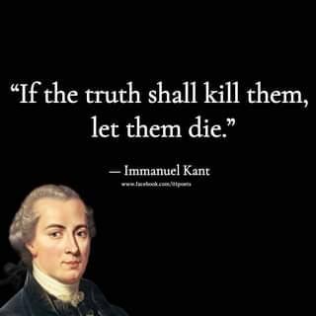

**(Absolutism) The view of Immanuel Kant**

[Kant & Categorical Imperatives: Crash Course Philosophy #35](https://www.youtube.com/watch?v=8bIys6JoEDw)

<https://www.youtube.com/watch?v=8bIys6JoEDw>

**Consequentialist Ethical Theories**

**Consequentialism** is a class of [normative](https://en.wikipedia.org/wiki/Normative_ethics), teleological [ethical theories](https://en.wikipedia.org/wiki/Ethics) that holds that the [consequences](https://en.wiktionary.org/wiki/consequence) of one's conduct are the ultimate basis for judgment about the rightness or wrongness of that conduct. Thus, from a consequentialist standpoint, a morally right act (or omission from acting) is one that will produce a good outcome. Consequentialism, along with [eudaimonism](https://en.wikipedia.org/wiki/Eudaimonism), falls under the broader category of **teleological ethics**, a group of views which claim that the moral value of any act consists in its tendency to produce things of [intrinsic value](https://en.wikipedia.org/wiki/Intrinsic_value_(ethics)). Consequentialists hold in general that an act is right *if and only if* the act (or in some views, the rule under which it falls) will produce, will probably produce, or is intended to produce, a greater balance of good over evil than any available alternative. Different consequentialist theories differ in how they define [moral goods](https://en.wikipedia.org/wiki/Value_theory), with chief candidates including pleasure, the absence of pain, the satisfaction of one's preferences, and broader notions of the "general good".

**(Uti-lita-ria-nism) The view of John Stuart Mill**

[Utilitarianism: Crash Course Philosophy #36](https://www.youtube.com/watch?v=-a739VjqdSI)

<https://www.youtube.com/watch?v=-a739VjqdSI>

[Utilitarianism | Ethics Defined](https://www.youtube.com/watch?v=-FrZl22_79Q)

<https://www.youtube.com/watch?v=-FrZl22_79Q>

[Utilitarianism in 4 Minutes](https://www.youtube.com/watch?v=mL7Pt-NHraU)

<https://www.youtube.com/watch?v=mL7Pt-NHraU>

[Utilitarianism - John Stuart Mill](https://www.youtube.com/watch?v=Dr9954kaFBs)

<https://www.youtube.com/watch?v=Dr9954kaFBs>

[PHILOSOPHY - Ethics: Utilitarianism, Part 1 [HD]](https://www.youtube.com/watch?v=uvmz5E75ZIA)

<https://www.youtube.com/watch?v=uvmz5E75ZIA>

[PHILOSOPHY - Ethics: Utilitarianism, Part 2 [HD]](https://www.youtube.com/watch?v=uGDk23Q0S9E)

<https://www.youtube.com/watch?v=uGDk23Q0S9E>

[PHILOSOPHY - Ethics: Utilitarianism, Part 3 [HD]](https://www.youtube.com/watch?v=MoCuVa9UeR4)

<https://www.youtube.com/watch?v=MoCuVa9UeR4>

**John Rawls’ Theory of Justice**

[Rawls Theory of Justice Summary .pdf](https://drive.google.com/file/d/1CzND9pfLcED4yL63RRMYrAJ5KuGX3AiM/view?usp=sharing)

<https://drive.google.com/file/d/1CzND9pfLcED4yL63RRMYrAJ5KuGX3AiM/view?usp=sharing>

[**A Theory of Justice Study Guide**](https://www.enotes.com/topics/theory-justice)

<https://www.enotes.com/topics/theory-justice>

[What Is Justice?: Crash Course Philosophy #40](https://www.youtube.com/watch?v=H0CTHVCkm90)

<https://www.youtube.com/watch?v=H0CTHVCkm90>

**Professional Ethics and Responsibilities for Computer Scientists and Engineers**

[Chapter 9 of the Sara Baase Book]

**A.1. Software Engineering Code of Ethics and Professional Practice**

[Software Engineering Code - ACM Ethics](https://ethics.acm.org/code-of-ethics/software-engineering-code/)

https://ethics.acm.org/code-of-ethics/software-engineering-code/

**A.2. ACM Code of Ethics and Professional Conduct**

[ACM Code of Ethics and Professional Conduct](https://www.acm.org/code-of-ethics)

<https://www.acm.org/code-of-ethics>

[**The System Administrators' Code of Ethics**](https://lopsa.org/CodeofEthics)

<https://lopsa.org/CodeofEthics>

[**SE Code of Ethics | CS 3240 - F20**](http://cs3240.cs.virginia.edu/f20/lecture/ethics/2020/09/16/secode.html)

<http://cs3240.cs.virginia.edu/f20/lecture/ethics/2020/09/16/secode.html>

[**Computer Ethics | Ethics, Laws, Definition & Privacy**](https://teachcomputerscience.com/computer-ethics/)

<https://teachcomputerscience.com/computer-ethics/>

[**IEEE CODE OF CONDUCT**](https://www.ieee.org/content/dam/ieee-org/ieee/web/org/about/ieee_code_of_conduct.pdf)

<https://www.ieee.org/content/dam/ieee-org/ieee/web/org/about/ieee_code_of_conduct.pdf>

[**IEEE Code of Ethics**](https://www.ieee.org/about/corporate/governance/p7-8.html)

<https://www.ieee.org/about/corporate/governance/p7-8.html>

**Ethical Decision Making in the field of IT and Computer Science:**

**Case studies, Group debate and Report Writing**

[**Thinking Ethically - Markkula Center for Applied Ethics**](https://www.scu.edu/ethics/ethics-resources/ethical-decision-making/thinking-ethically/)

<https://www.scu.edu/ethics/ethics-resources/ethical-decision-making/thinking-ethically/>

[**A Framework for Ethical Decision Making**](https://www.scu.edu/ethics/ethics-resources/a-framework-for-ethical-decision-making/)

<https://www.scu.edu/ethics/ethics-resources/a-framework-for-ethical-decision-making/>

[**An Introduction to Cybersecurity Ethics**](https://www.scu.edu/media/ethics-center/technology-ethics/IntroToCybersecurityEthics.pdf)

<https://www.scu.edu/media/ethics-center/technology-ethics/IntroToCybersecurityEthics.pdf>

**Steps to Ethical Decision Making (by *Sara Baase*):**

**Textbook:** S. Baase, ***A Gift of Fire: Social, Legal, And Ethical Issues For Computing Technology*** *(4th edition)*, Boston, MA, United States: Prentice Hall, 2012.

**Reference:**

A. Adams and R. J. McCrindle, *Pandora’s box: Social and professional issues of the information age*. Chichester, England: Wiley, John & Sons, 2008.

J. M. Kizza, *Ethical and social issues in the information age, 5th ed.* London: Springer-Verlag New York, 2013.

**Brainstorming phase:**

* List all the people and organizations affected. (They are the stakeholders.)
* List risks, issues, problems, consequences.
* List benefits. Identify who gets each benefit.
* In cases where there is not a simple yes or no decision, but rather one has to choose some action, list possible actions.

**Analysis phase:**

* Identify responsibilities of the decision maker. (Consider responsibilities of both general ethics and professional ethics, as per ACM/SE Codes of Ethics.)
* Identify the rights of stakeholders. (It might be helpful to clarify whether they are negative or positive rights)
* Consider the impact of the action options on the stakeholders.
* Analyze consequences, risks, benefits, harms, and costs for each action considered.
* Consider Kant’s, Mill’s, and Rawls’ approaches.
* Then, categorize each potential action or response as ethically obligatory, ethically prohibited, or ethically acceptable.

**Decision Phase:**

If there are several ethically acceptable options, select an option by considering the ethical merits of each, courtesy to others, practicality, self-interest, personal preferences, and so on. (In such a case, plan a sequence of actions, depending on the response to each.)

# Mini Project-3: Present an ethical dilemma in decision making in the field of IT.

**Activity:** Criticism and justification of actions/stance as per ethical frameworks

Case studies with **group presentation and opposition**

**Own report writing and Opposition report writing**

**The Report should contain (Limit 4 pages)**

* Details of a case/scenario that involves an ethical dilemma and requires decision making in an ethical manner
* Identify the dilemma clearly and the possible/probable decisions
* Justification of the chosen decision based on the Ethical Theories following the steps to ethical decision making.
  + Brainstorming Phase
  + Analysis Phase
  + Decision Phase

Topics could be:

* Self-driving cars (The Moral Machine)
* Use of machine learning for adversarial purpose (Uyghur Detection Dataset)
* Social Rating System
* Limits to Ethical Hacking
* Trustworthiness of AI
  + [Trustworthy AI and the foundations of AI systems - Ericsson](https://www.ericsson.com/en/blog/2020/12/trustworthy-ai)
  + [AI – Ethics inside? - Ericsson](https://www.ericsson.com/en/reports-and-papers/industrylab/reports/ai-ethics)
  + [AI bias and human rights: Why ethical AI matters - Ericsson](https://www.ericsson.com/en/blog/2021/11/ai-bias-what-is-it)
  + [Trustworthy AI | IBM](https://www.ibm.com/watson/trustworthy-ai)
  + [AI Ethics | IBM](https://www.ibm.com/artificial-intelligence/ethics)
  + [Ethics guidelines for trustworthy AI | Shaping Europe’s digital future](https://digital-strategy.ec.europa.eu/en/library/ethics-guidelines-trustworthy-ai)
* More topics could be found in: [Ethics of artificial intelligence - Wikipedia](https://en.wikipedia.org/wiki/Ethics_of_artificial_intelligence)
* Chapter 9 of the Book: A Gift of Fire by Sara Baase.

**Resources:**

**Links:**

[Moral Machine](https://www.moralmachine.net/)

[The Moral Machine experiment | Nature](https://www.nature.com/articles/s41586-018-0637-6)

[Moral Machine - Wikipedia](https://en.wikipedia.org/wiki/Moral_Machine)

[Why the moral machine is a monster](https://robots.law.miami.edu/2019/wp-content/uploads/2019/03/MoralMachineMonster.pdf) [PDF]

**TED talks:**

The ethical dilemma of self-driving cars - Patrick Lin

<https://www.youtube.com/watch?v=ixIoDYVfKA0>

The Social Dilemma of Driverless Cars - Iyad Rahwan

<https://www.youtube.com/watch?v=nhCh1pBsS80>

The Greater Good - Mind Field S2 (Ep 1: The Trolley Problem in Real life)

<https://www.youtube.com/watch?v=1sl5KJ69qiA>

|  |
| --- |
| **The following will be the drill for debate session:**   * ***The defending group will have 6 minutes to complete their presentation.*** * ***Then the opponent group will have 3 minutes to present the opposition, and keep the screen on until the end of the session.*** * ***Then the defending group will have 1 minute to present for the rebuttal.*** * ***Open discussion/debate on the decision will follow for 2 minutes.*** |

**The following will be the drill for debate session:**

* ***The defending group will have 6 minutes to complete their presentation.***
* ***Then the opponent group will have 3 minutes to present the opposition, and keep the screen on until the end of the session.***
* ***Then the defending group will have 1 minute to present for the rebuttal.***
* ***Open discussion/debate on the decision will follow for 2 minutes.***

**The Defending group** shall present their work for 6 minutes. This could be 3 x 2 minute presentations, or the group leader may present the whole presentation.

**The defense presentation (6 minutes) and the report (limit: 4 pages) should highlight:**

* The presented scenario and the probable decisions
* The ethical dilemma associated with each of the decisions
* Analysis of each of the decisions showing every steps of the decision making process (both brainstorming and analysis phase) [*should be emphasized*]
* Responsibility of you as a decision maker and the rights of the stakeholders
* Justification of the chosen decision based on the ethical theories [**most emphasis should be given**]

**The opposition report should be submitted before 23:55**

**The opposition report (limit: 2 pages) and presentation (3 minutes) should highlight**

* Summary of the opponents’ scenario and ethical dilemma
* Strongest aspect of the opponents’ work
* Weakest aspect of the opponents’ work
* Suggestions/Criticisms to the opponents’ decision [**most emphasis should be given**]

**The defending group shall refute the opponents’ criticisms for 1 minute, followed by an open discussion/debate session for 2 minutes.**

**Marks distribution of the MP-3 will be as follows:**

|  |  |
| --- | --- |
| **Activity** | **Mark** |
| Project Report | 5 |
| Defense Presentation | 2 |
| Opposition Report | 3 |
| Opposition Presentation | 3 |
| Rebuttal/Open Discussion | 2 |
| Total | 15 |

**<Final>**

# Knowledgebase

## CVE

Common Vulnerabilities and Exposures (CVE) is a number assigned to a discovered vulnerability.

Find what CVE-2023-3079 is, and how it works.

<https://nakedsecurity.sophos.com/2023/06/06/chrome-zero-day-this-exploit-is-in-the-wild-so-check-your-version-now/>

CWE

BID

## Hash Functions

## Security Operations Center (SOC)

A Security Operations Center (SOC) is a team of cyber security professionals that monitors the network and its systems to detect malicious cyber security events.

Some of the main areas of interest for a SOC are:

**Vulnerabilities:** Whenever a system vulnerability (weakness) is discovered, it is essential to fix it by installing a proper update or patch. When a fix is not available, the necessary measures should be taken to prevent an attacker from exploiting it. Although remediating vulnerabilities is of vital interest to a SOC, it is not necessarily assigned to them.

**Policy violations:** We can think of a security policy as a set of rules required for the protection of the network and systems. For example, it might be a policy violation if users start uploading confidential company data to an online storage service.

**Unauthorized activity:** Consider the case where a user’s login name and password are stolen, and the attacker uses them to log into the network. A SOC needs to detect such an event and block it as soon as possible before further damage is done.

**Network intrusions:** No matter how good your security is, there is always a chance for an intrusion. An intrusion can occur when a user clicks on a malicious link or when an attacker exploits a public server. Either way, when an intrusion occurs, we must detect it as soon as possible to prevent further damage.

#soc

## Smurf Attack

A Smurf Attack is a type of DDoS attack that involves sending a large number of ICMP echo request packets (pings) to a network's broadcast address using a spoofed source IP address. The ICMP packets are broadcast to all devices on the network, causing them to respond with ICMP echo replies, overwhelming the target network and making it unavailable to legitimate users.

The Smurf Attack is based on the fact that many network devices are configured to respond to ICMP echo requests by default, and will automatically send an ICMP echo reply to the source IP address of the request. The attacker spoofs the source IP address in the ICMP echo requests, making it appear as if they are coming from the target network, and sends them to the broadcast address of the network. The result is that all devices on the network respond to the spoofed requests, generating a large amount of traffic and causing a DDoS attack.

The name "Smurf" comes from the fact that the first widespread use of this attack was against the Smurfs cartoon website in 1997. The attack was able to bring down the website for several days, causing significant disruption.

To protect against Smurf Attacks, network administrators can disable ICMP broadcast responses on their network devices or configure their firewalls to block ICMP packets from the network's broadcast address. Additionally, Internet Service Providers can implement network-level filtering to block ICMP packets with spoofed source IP addresses, preventing them from being transmitted over their network.

## Teardrop Attack

The Teardrop attack is a type of denial-of-service (DoS) attack that exploits a vulnerability in the way that some operating systems reassemble fragmented packets. In a Teardrop attack, the attacker sends a series of IP fragments to the target system with overlapping offsets, causing the target's operating system to fail when it tries to reassemble the packets.

When a large packet is transmitted over a network, it is often broken down into smaller fragments to be transmitted more efficiently. The receiving system then reassembles the fragments into the original packet. However, in the Teardrop attack, the attacker sends fragmented packets with overlapping offsets, causing the receiving system to become confused and fail when attempting to reassemble them.

The Teardrop attack can cause the target system to crash or become unresponsive, rendering it unavailable to legitimate users. The attack can be carried out with relatively simple tools and requires little technical knowledge.

The Teardrop attack was a prevalent form of DoS attack in the late 1990s but is now less common due to the implementation of better packet reassembly algorithms in modern operating systems. However, it is still possible to carry out Teardrop attacks against older or less secure systems. To protect against Teardrop attacks, system administrators should ensure that their systems are running the latest security patches and that their firewalls are configured to block fragmented packets with overlapping offsets.

1. *Please note that the given data is for illustrative purposes only and may not reflect the actual AS numbers, country details, registrar organizations, and allocated public IP addresses of the organizations mentioned. It is advisable to use the suggested resources to obtain accurate and up-to-date information.*